Kubernetes - Architecture

# Different Architecture Types

## High Availability Server Cluster

The typical kubernetes architecture is designed for high-availabilty (HA) and redundancy. HA clusters tend to have:

* three or more server nodes running the control plane
* external datastore for the control plane
* many worker nodes

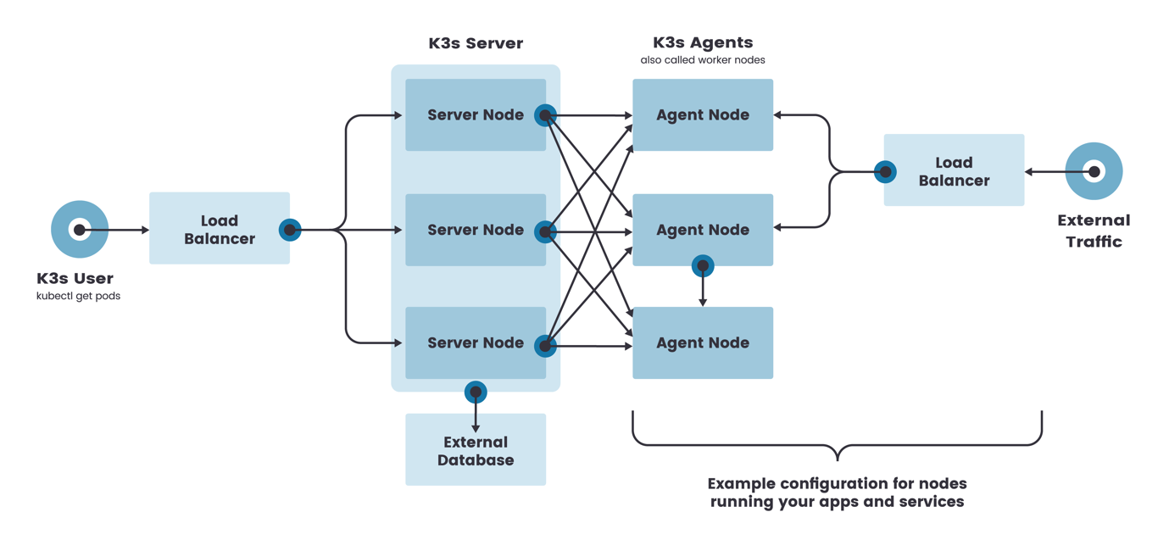

## Single Node Server Cluster

Single node server clusters are generally used on small machines with limited resources. Due to the hardware constraints, they use reduced versions of kubernetes such as K3s and kubeadm as outlined below:

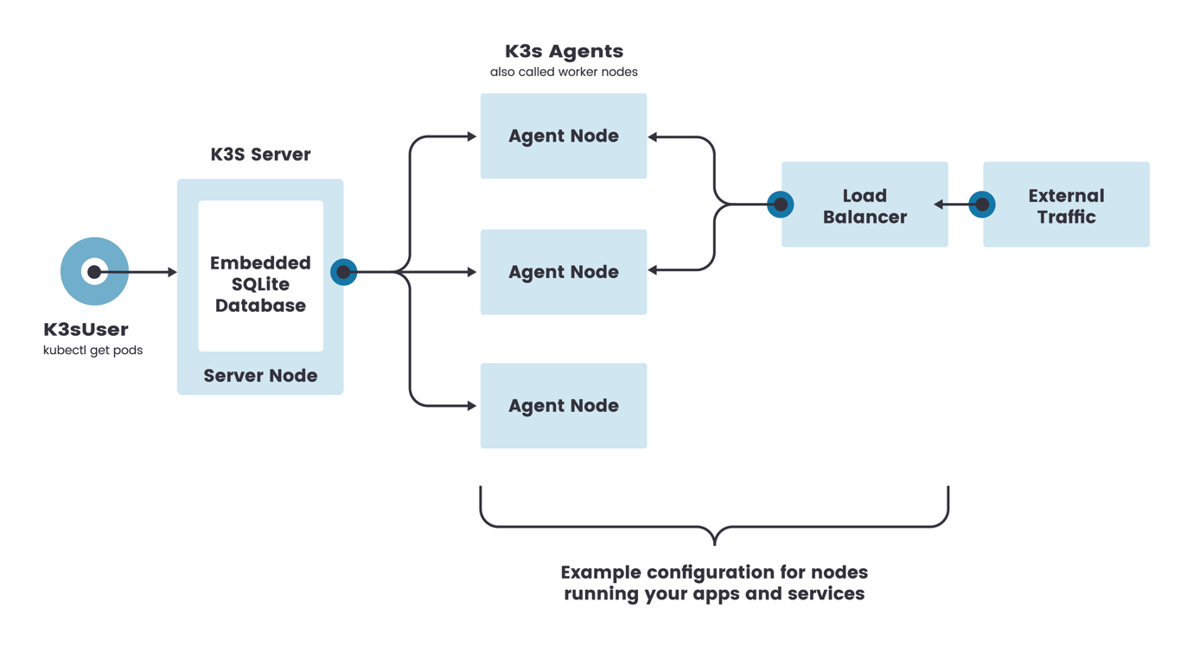

# Creating k3s single node cluster

## Install k3s

<https://github.com/rancher/k3s>

Add config to local machine, get config from:

sudo cat /etc/rancher/k3s/k3s.yaml

add to limited access (600) file:

~/.kube/config

modify server location to match control plane

## Configure Traefik